Quick Look: Vendor Responsibility Accepting Supplemental Tokens/Coupons All Programs
- Vendor must display a sign that shows what type of program or programs they are authorized to accept. (Provided)
- Approved products must be labeled including price.
- Customer shops for applicable program approved item(s).
- Vendor confirms the token, coupon, and/or coupon holder is current approved format required.
- It is illegal to give change. Vendor helps customer pick items to get full value of token/coupon.
- Vendor turns in collected tokens/coupons to market manager at end of day and verifies with signature on return record.
- Vendor handles coupons and tokens as if cash.
Program Specific Requirements
SNAP Program
- Customer picks “approved” items to purchase. Vendor verifies all items are approved. (See list)
- Customer “pays” for purchases with $1.00 token (green ink only). Vendor checks token to ensure it is current approved token.
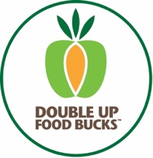
Double Up Food Bucks
- Customer picks approved items to purchase (Fruits & Vegetables Only). Vendors verify all items fit approval.
- Customer “pays” for purchase with $2.00 silver token. Check token to ensure it is current approved token.
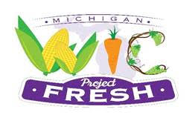
Project FRESH
- Customer presents a purple coupon and its coupon holder to vendor which he/she has signed on the front cover of the holder and also on the coupon itself. Vendor confirms coupon date is current year June 1st to October 31st.
- Vendor checks customer’s signature on the front cover of the customer’s coupon holder to confirm it matches signature on the coupon itself. Vendor returns coupon holder to customer.
- Customer presents items to purchase (fruits and vegetables only) and pays for purchases with a $5.00 coupon.
- Vendor’s assigned farmer number will be indicated on your signed copy of the Project FRESH agreement. Please write this number in the appropriate space on the coupons before you submit them to the market cashier.

Senior Project FRESH
- Customers receive a minimum of ten $2.00 yellow 2018 coupons to purchase fresh fruits, vegetables, herbs, spices, and honey.
- Customers must be residents of Calhoun county.
- Customers are instructed to sign the coupon register and the coupon holder. Customers may have another person authorized to purchase their produce. If so, the proxy will also sign the coupon register and the coupon holder. Vendors must compare signatures.
- Coupons are valid from May 1 to October 31 each year they are given out. Be sure you are accepting current coupons only.
- Only fresh, unprepared, locally-grown fruits, vegetables, herbs, spices, and honey may be purchased with Market FRESH coupons. To be eligible, produce must be Michigan-grown or grown in counties directly bordering Michigan. (Eaton, Barry, Jackson, Kalamazoo, Hillsdale, Branch, St. Joseph)
- You will be assigned a farmer number which will be indicated on your signed copy of the Market FRESH agreement. Write this number in the appropriate space on the coupons before you submit them to the market cashier and sign a receipt. The market is also assigned a number which is also indicated on the form that number is 614.

