Marshall Area Farmers’ Market
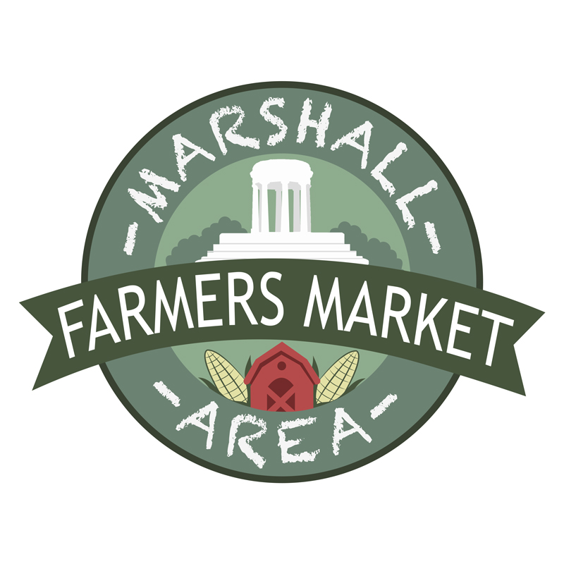
Vendor Agreement for SNAP EBT Bridge Card Program
This agreement is between the Marshall Area Farmers’ Market (MAFM) and the eligible vendors who participate in the program. MAFM will accept Supplemental Nutrition Assistance Program (SNAP) benefits via the Michigan EBT SNAP Bridge Card.

TOKENS: Customers decide how much they want to spend and then visit the MAFM tent to swipe their SNAP card to receive a token. The value of each token is $1.00 (Green copy). The token can only be used at the Marshall Market. Customers are encouraged to use the token on the day they receive it or they may return the token to refund their Bridge card before the market closes for the day.

WHAT MAY BE PURCHASED WITH TOKENS: Tokens may be used to purchase any eligible food item meant for human consumption. This includes the four basic food groups, breads, cereals, daily products, fresh fruit, and vegetables; and meat, fish, and poultry as well as snack foods. SNAP Bridge tokens may also be used to purchase seeds or plants that produce food.

WHAT MAY NOT BE PURCHASED WITH TOKENS: Tokens may NOT be used to purchase hot or prepared foods meant for immediate consumption or non-food items such as cut flowers, decorative plans and/or pet food.

OTHER PROGRAM REQUIREMENTS:
- NO change can be given for tokens. It is illegal to exchange cash for SNAP benefits. We encourage vendors to add or subtract product in order to create an even dollar amount if the customer does not have exact change.
- Vendors must post the SNAP Bridge Card Sign provided by MAFM to identify their booth and as a place where SNAP tokens can be used.
- Products must be priced the same for the SNAP customer as for all customers.
- Return all tokens at the end of the market day in which you collected it; sign the submission form.
- Damaged tokens or tokens not accepted for eligible products will not be reimbursed
- Vendors are responsible for reading and complying with SNAP rules and procedures which can be found on-line at www.michigan.gov/mdard./
- I understand it is my responsibility to inform a representative of my business including employees and volunteers of these rules before they sell at the market on behalf of my business.

REIMBURSEMENT: Vendors must turn in all tokens accepted at the end of the market day to a MAFM representative. MAFM will submit for reimbursement to the vendor monthly.

AGREEMENT: I agree to accept tokens for the SNAP EBT CARD PROGRAM and follow all the rules above. I understand that if market staff observe or receive evidence of my failure to abide by this agreement, I will not be reimbursed for the tokens collected incorrectly, the market will immediately suspend or terminate my approval to accept food assistance benefits, and the offense may affect my ability to participate in the market.

Business Name Please print business name

Signature of Vendor Representive Date

