CITY OF MARSHALL
PUBLIC HEARING NOTICE

The Marshall City Council will be holding a public hearing on Monday, May 1, 2023 at 7:00 p.m. in the Board of Commission Chambers of the Marshall County Building, 315 W Green St, Marshall, MI 49068. The purpose of the meeting will be to consider the following items:

- Public Hearing for Rezoning Application RZ 23.01 for the rezoning of 13700 W Michigan Ave, parcel 53-281-021-00, which contains parcels that were transferred under a PA 425 agreement with Marshall Township from Township Zoning to Industrial and Manufacturing Complex (I-3)
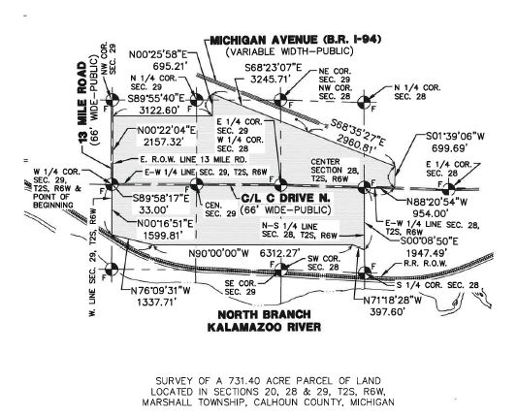
The following parcels or portions of parcels that are included in the above map are included in the rezoning request:

16-201-021-00 16-290-006-00 16-291-009-00 16-201-015-00 16-282-006-00
16-281-021-00 16-290-009-00 16-291-015-00 16-282-003-00 16-290-024-00
16-291-012-00 16-290-018-00 16-290-021-01 16-290-021-02 16-290-021-03
16-290-021-04 16-290-021-05 16-281-015-01 16-281-015-02 16-281-015-05

Any property owner or their representative, or any interested person is invited to attend the meeting to be held as noticed above. Those wishing to comment may do so in person at the meeting or may send written comments to the attention of Eric Zuzga, City of Marshall, 323 W. Michigan Ave., Marshall, Michigan 49068.

The City of Marshall will provide necessary and reasonable auxiliary aids and services to individuals with disabilities at the hearing upon reasonable notice to the City Clerk of the need for the same. Individuals with disabilities requiring auxiliary aids or services should contact the office of the City Clerk at least four (4) days prior to the hearing. The City Clerk’s Office can be reached at phone: 269-781-5183 or in-person at the location and times indicated below.

A copy of the ordinance may be obtained, inspected, or reviewed in the Office of the Clerk, Monday-Friday, between the hours of 8:30AM-12:00PM and 1:00PM- 4:00PM. The Clerk’s Office is located at City Hall, 323 West Michigan Avenue, Marshall, MI 49068. The Clerk’s Office can be reached at 269-781-5183.

